Marwadi University
Faculty of Computer Applications

BCA 4E Python Mid-1 Exam

Enrollment No. : 92400527002
Name : Walter M Musa
Class : SET-1 BCA 4E
Date : 03/12/2026

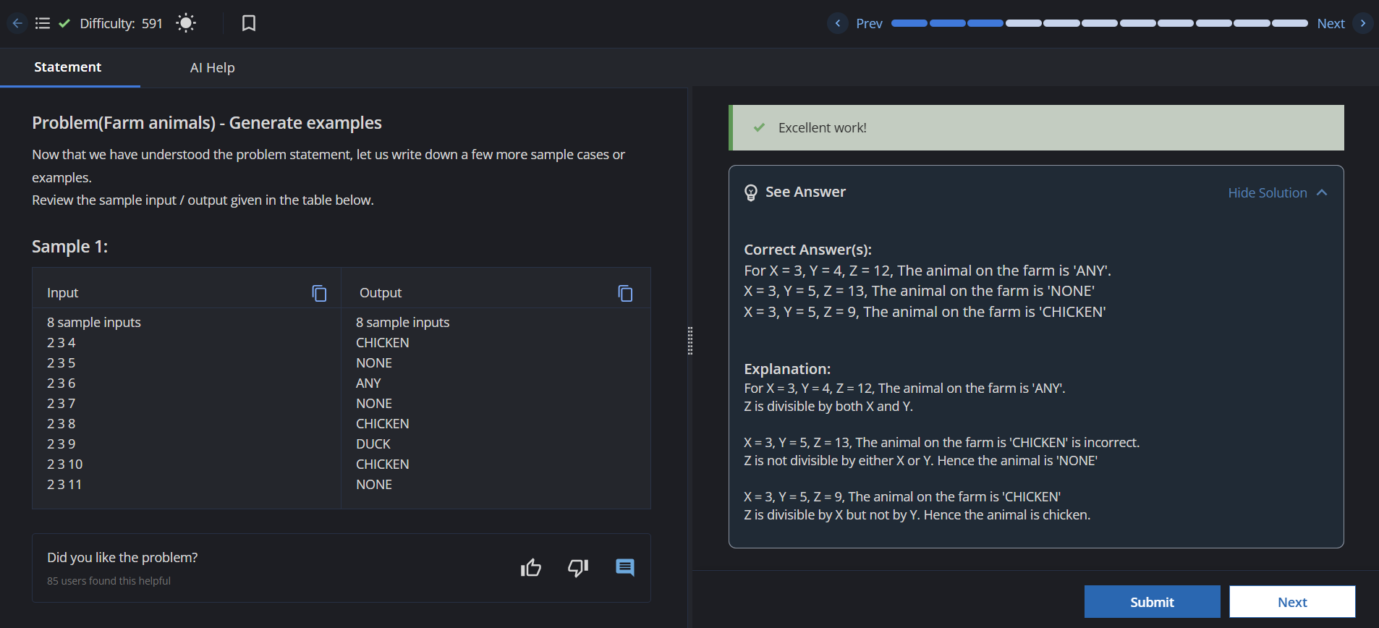

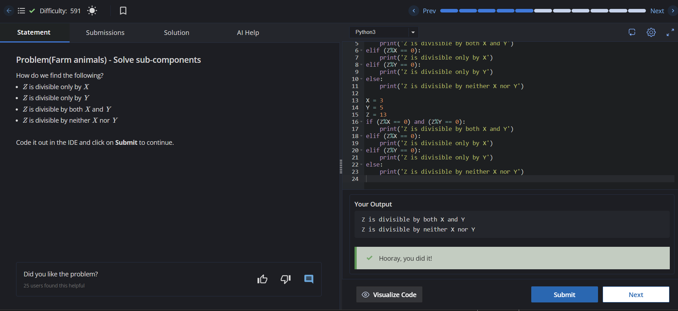

Answer – 3
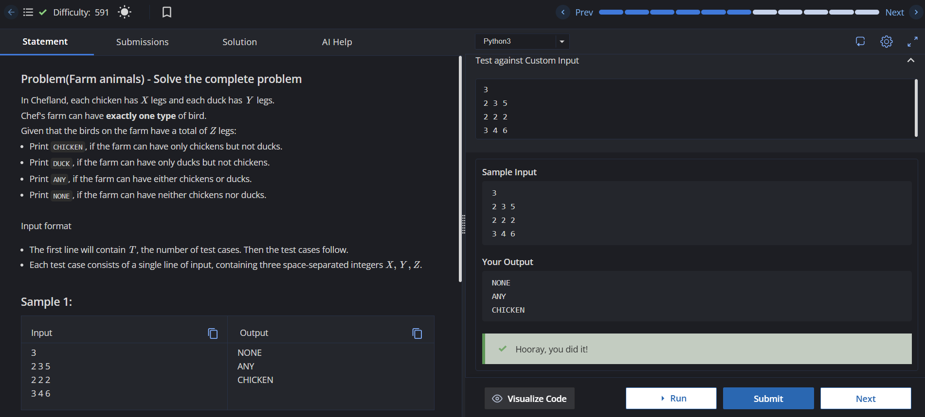
Answer – 4
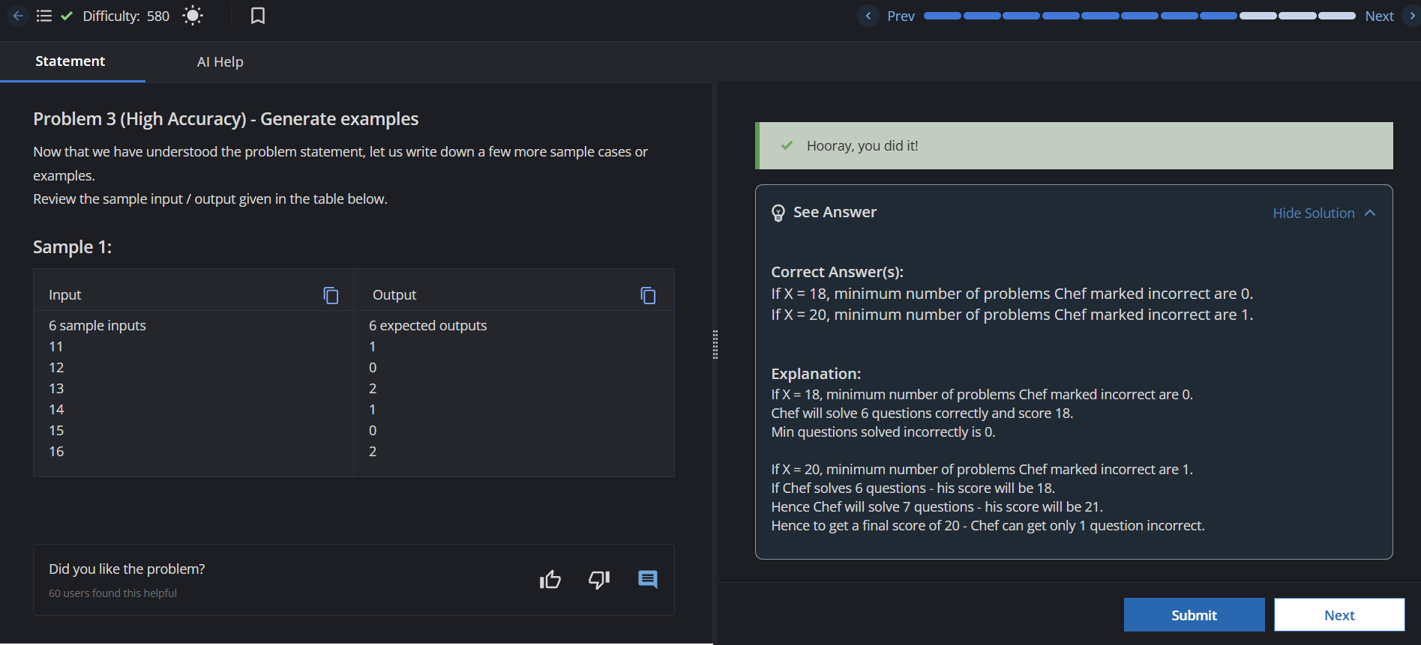

Answer - 5

